Deep Learning Question Bank
- Illustrate the operation of pooling layer in CNN with simple example.
- What is unsupervised learning, and how can deep neural networks be used for unsupervised learning tasks?
- What is the working principle of LSTM networks, and how are they used in deep learning applications?
- Explain the Deep Learning Architecture for IoT/Edge Devices.
- Explain Deep reinforcement learning with a suitable example.
- Consider the given data set, Apply Naive Bayes algorithm and predict that if a fruit has the following properties, then which type of fruit it is:
Fruit ={yellow, sweet, long}
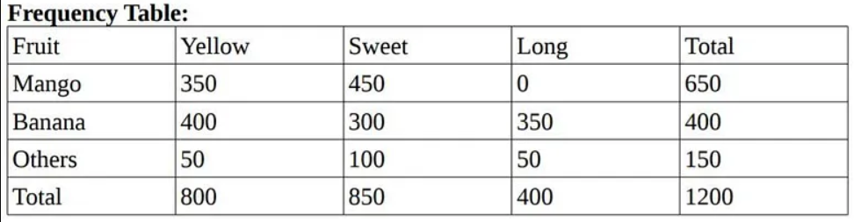
- Explain the structure and working principle of autoencoders and decoders, and explain how they can be used for unsupervised learning tasks, such as dimensionality reduction and anomaly detection.
- Discuss the working principle of recurrent neural networks, and explain how they can be used to process sequential data.
- Implement AND function using perceptron networks for bipolar inputs and targets. The initial weights and threshold are set to zero. The learning rate is set equal to 1. Calculate upto 2 epochs.
- Explain the process of gradient descent and its role in optimizing the weights and biases of a neural network. How does it help in improving the accuracy of a deep learning model?
- What are the building blocks of a convolutional neural network, and how are they used to extract features from input data?
- What is the working principle of variational autoencoders, and how are they used in generative modeling?
- Explain Deep Learning Architecture for Speech and Audio Processing.
- Explain Deep Learning Architecture for Natural Language Processing.
- Discuss the concept of backpropagation in neural networks. How is it used to calculate the error and update the weights and biases of the network during training?
- Discuss the working principle of generative adversarial networks, and explain how they can be used for generative modeling tasks, such as image generation and data synthesis.
- Implement AND function using McCulloch-Pitts neuron (take binary data).
- What is the XOR problem, and how can it be solved using an artificial neural network?
- How do the momentum optimizer, RMSProp, and Adam optimization algorithms differ from each other in deep learning?
- Explain the process of gradient descent and its role in optimizing the weights and biases of a neural network. How does it help in improving the accuracy of a deep learning model?
- Discuss the properties of Convolutional Neural Networks representations: invertibility, stability, invariance and what will be the impact of achieving these properties in any network.
- Develop a block diagram for LSTM (Long Short term memory).
- Describe the architecture of Capsule model. Describe its need and how it is different from traditional models.
- Justify your answer, that how autoencoders are suitable compared to Principal Component Analysis for dimensionality reduction.
- Explain gradient descent optimization.
- Give the blocks of decomposition of computation of most recurrent neural networks.
- Explain the propertied of convolution layers and their role in feature extraction. Define and analyze the significance of pooling layers in CNNs.
- Discuss the differences between autoencoders and GAN in terms of functionality and applications.
- Describe the architecture of deep reinforcement learning model. Discuss the applications of deep learning in IoT and edge devices.
- Develop a GAN to generate synthetic images of handwritten digits. Highlight training challenges and solutions.
- Design a deep learning pipeline for real time video surveillance using edge devices. Discuss challenges and optimizations.
- Propose a strategy for handling missing data in temporal sequences for RNN based models. A company wants to use RNNs for analyzing customer purchase patterns. Design an architecture and discuss potential challenges.
- Explain how invariance and covariance are balanced in convolutional architectures. A company used CNNs for vehicle classification from traffic images. Propose improvements to enhance stability and accuracy under varying lighting conditions.
- What is bias-variance tradeoff? Given a model that consistently overfits, analyze potential causes and suggest solutions.
- Describe the stability and invariance properties of CNN representations with examples.
- Describe the architecture of variational autoencoders (VAEs) and their use in generative tasks.
- Explain how temporal datasets are processed for RNNs and LSTMs. Propose a strategy for handling missing data in temporal sequences for RNN based models.
- Analyse the challenges of applying deep learning in natural language processing.
- What is gradient descent? A financial institution wants to use deep learning to predict loan defaults. Identify challenges in handling high dimensional data and propose solutions.
- A retail company wants to predict product categories from images using CNNs. Explain how embedding layers can help improve model performance for a multiclass dataset.
- Describe Van and compare the outputs of a VAE and a GAN when generating images of faces. Discuss the differences in quality and diversity.
- Design and develop a reinforcement learning model for robotic control. Explain the training process and evaluation metrics.

